ls ‘Deskop/Demo1/folder1’ ‘Desktop/demo/folder1’- It shows the list of files present at this location.

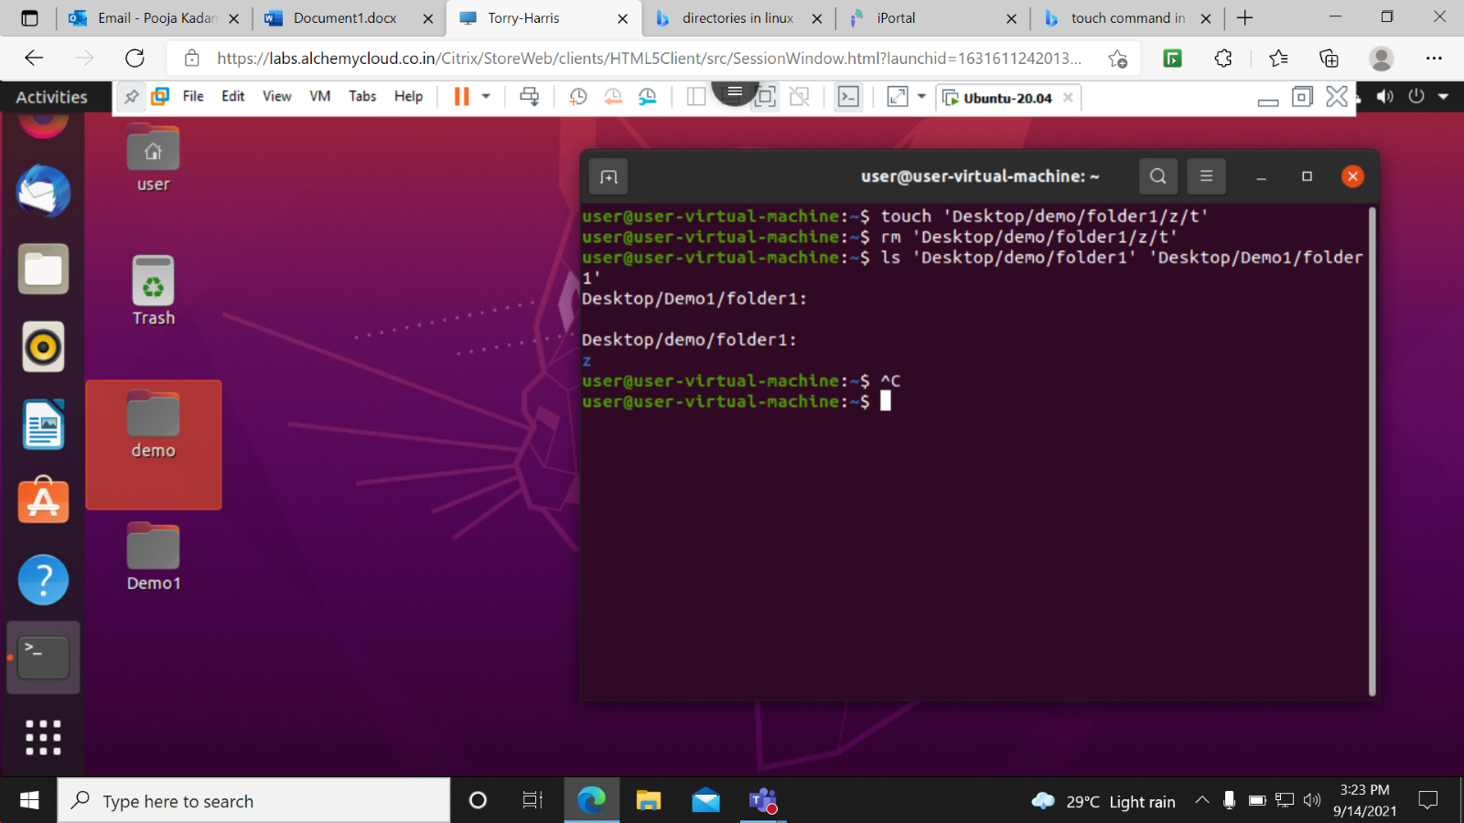

cp –r ‘Desktop/demo/folder1’ ‘Desktop/Dem1/folder1’- Used to cut content from 1st location and paste it on 2 nd location.

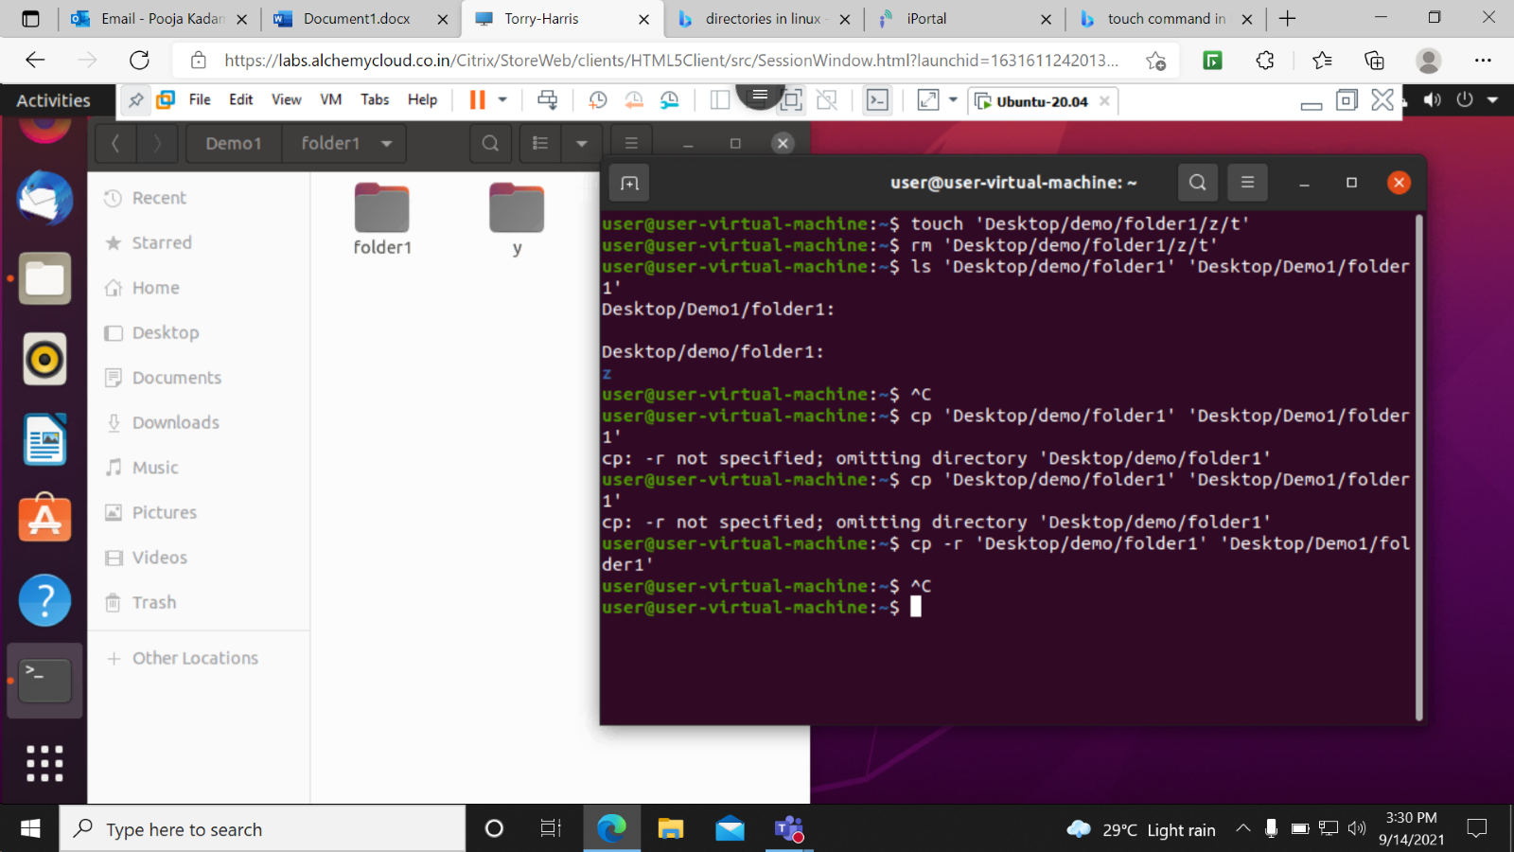

cat x- It shows the list of document or text inside the file.

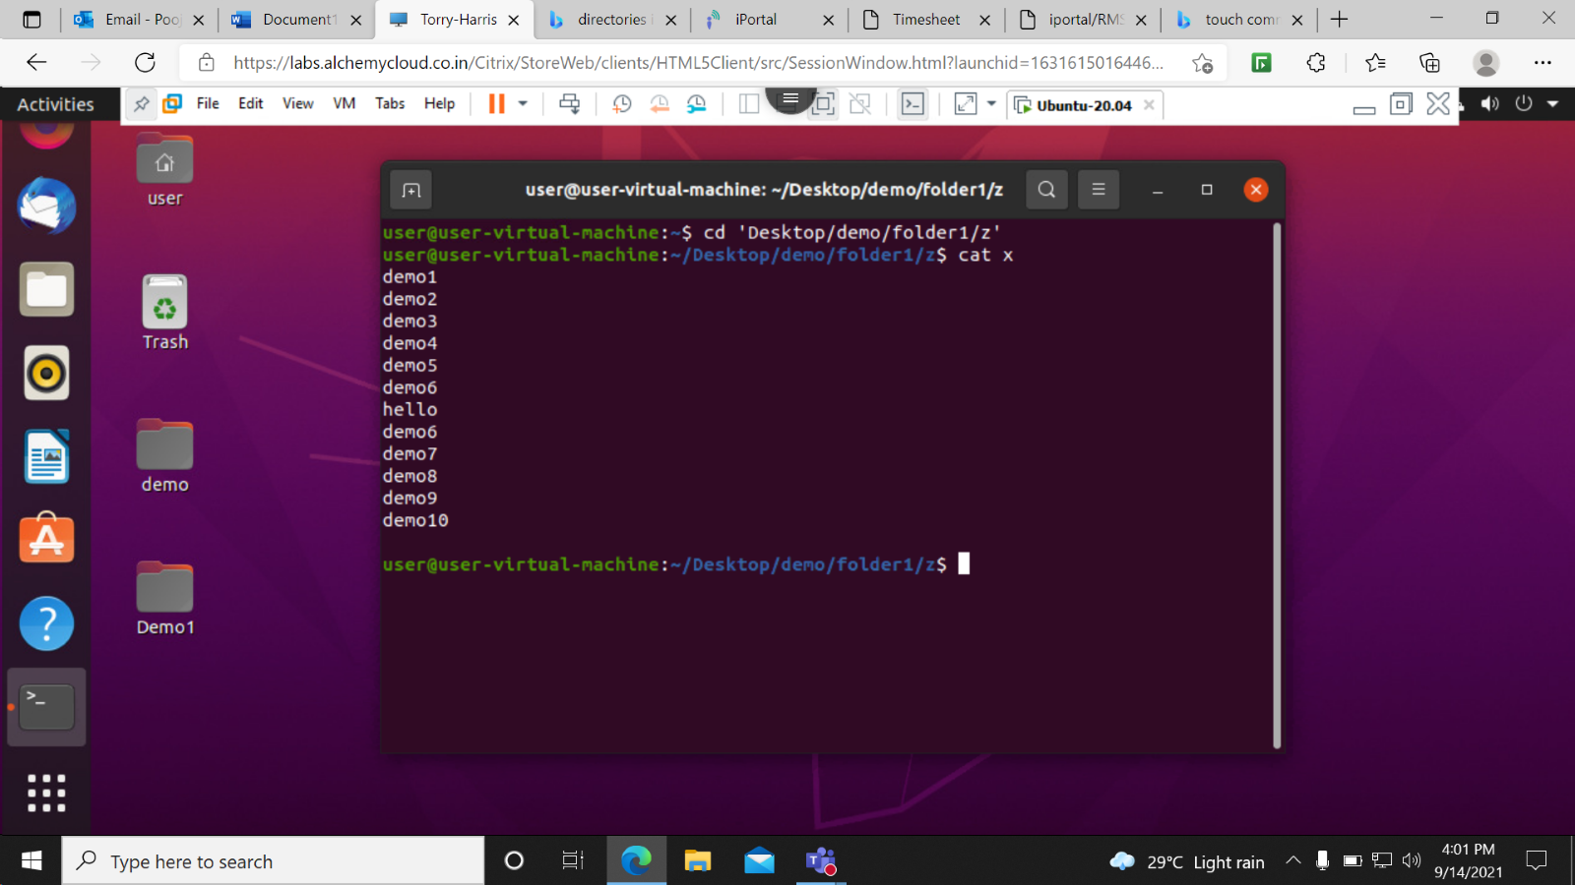

cat x z-It is used to merge x and z files.

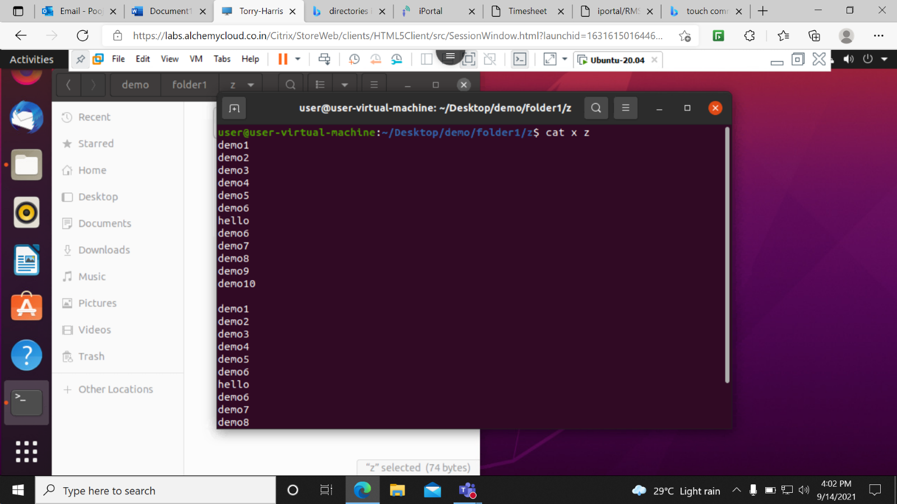

mkdir -p 1/2/3/4- It is used to create folder inside a folder I,e a loppinf folder.

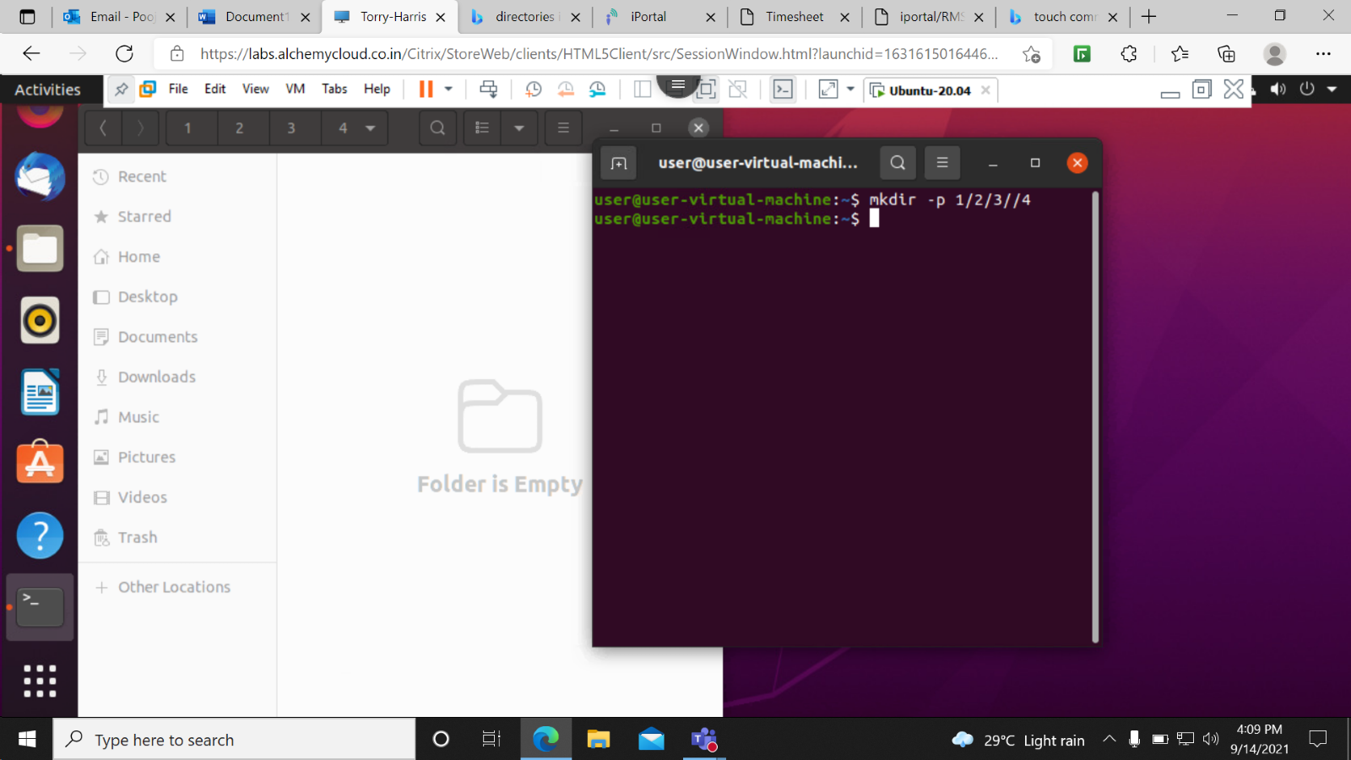

rm -rf 123- it is used to delete the folder named as 123.

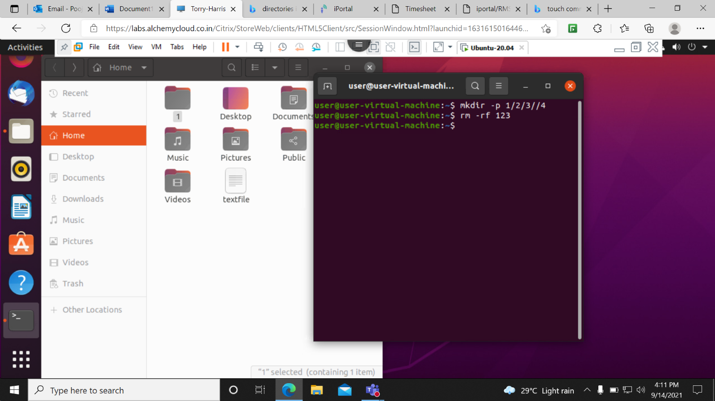

ls -l-a-This is used to display the hidden files.

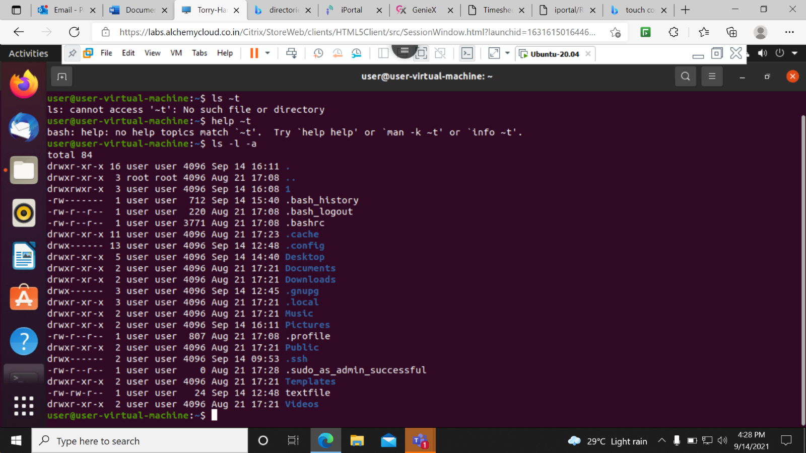

ls -l –a –r- This command is used to display all files in reverse order.

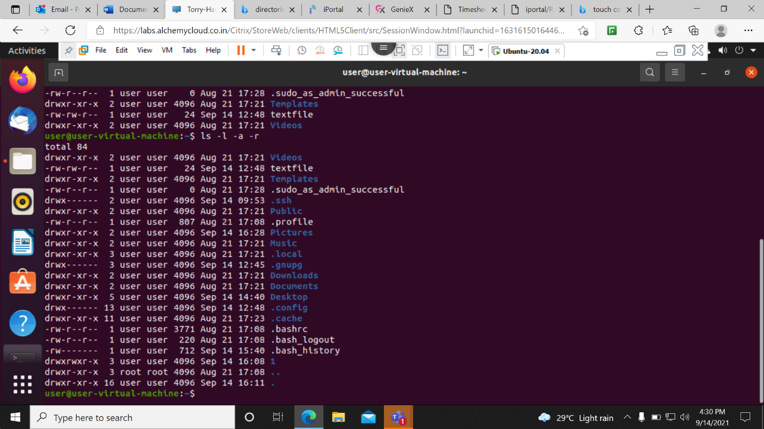

passwd-This command is used to change the password.

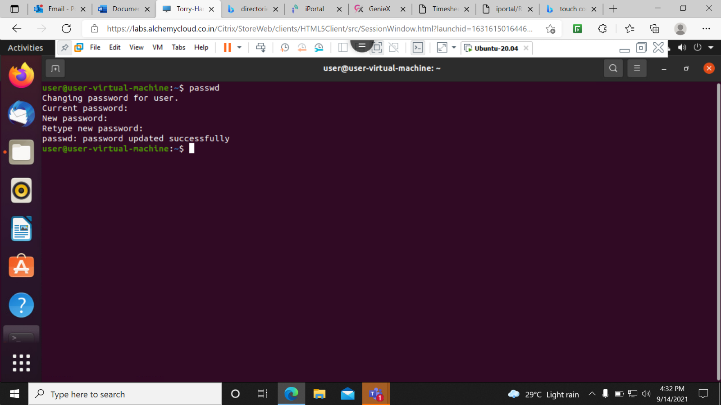

Sudo apt install free # version 1.8.0.1- This command is used to install the tree package.

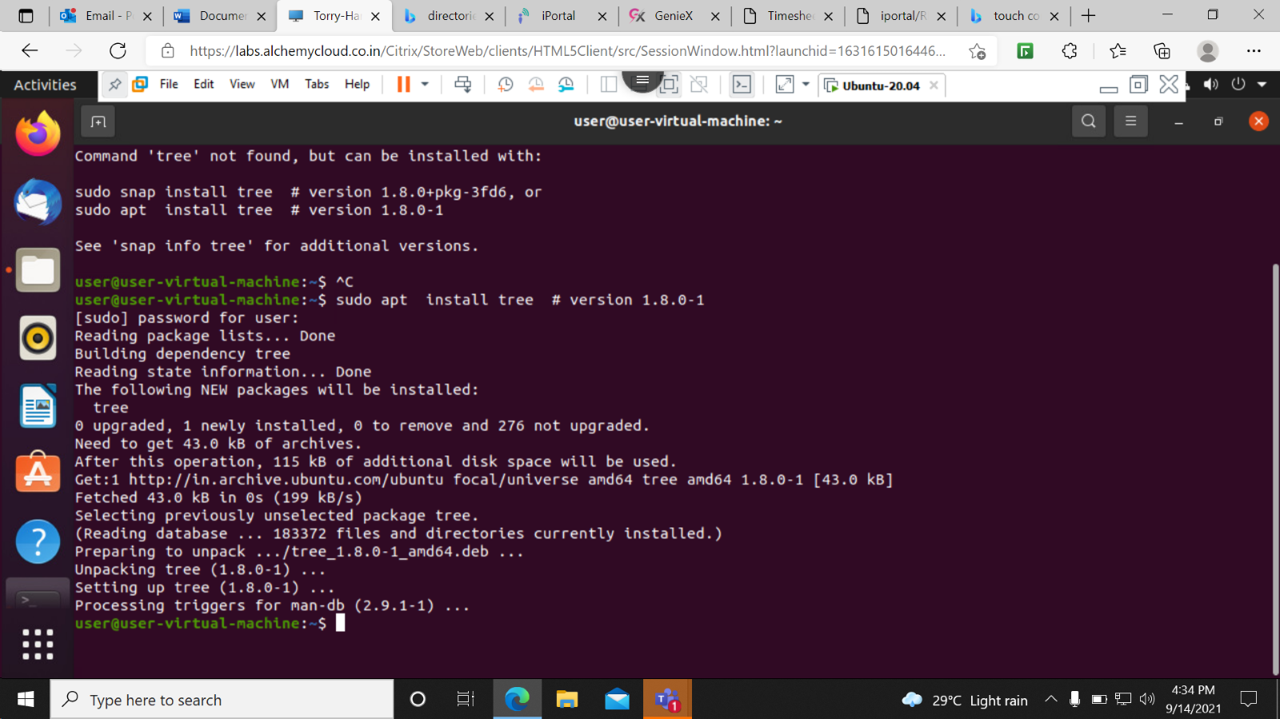

tree -d – This command is used to print directory in the current folder.

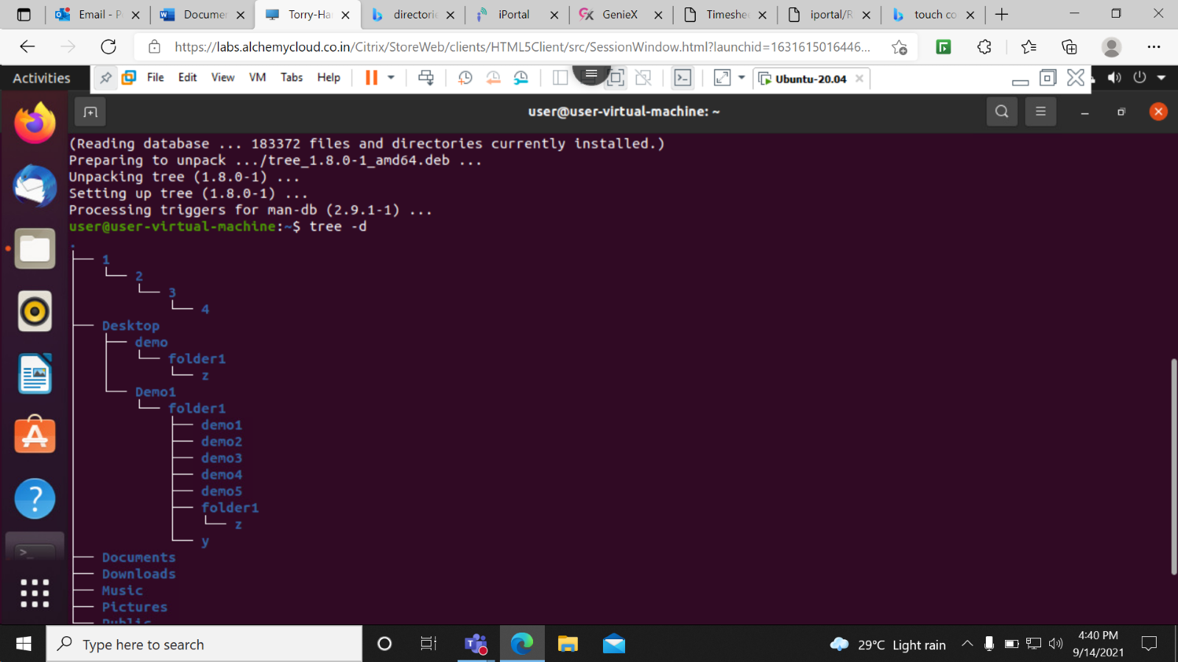

sudo apt-get update-this command is used to update the libries.

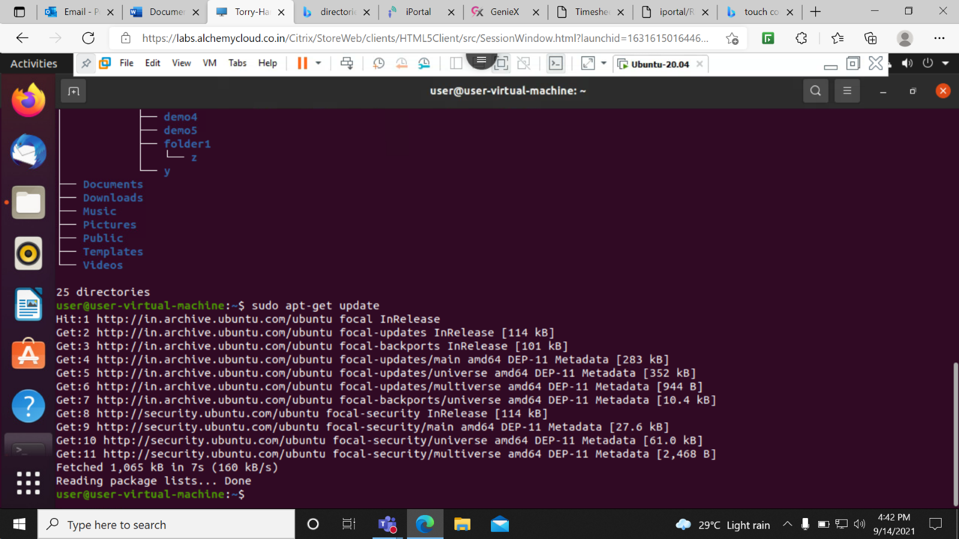

sudo apt-get upgrade-This command is used to upgrade the libries to install libries.

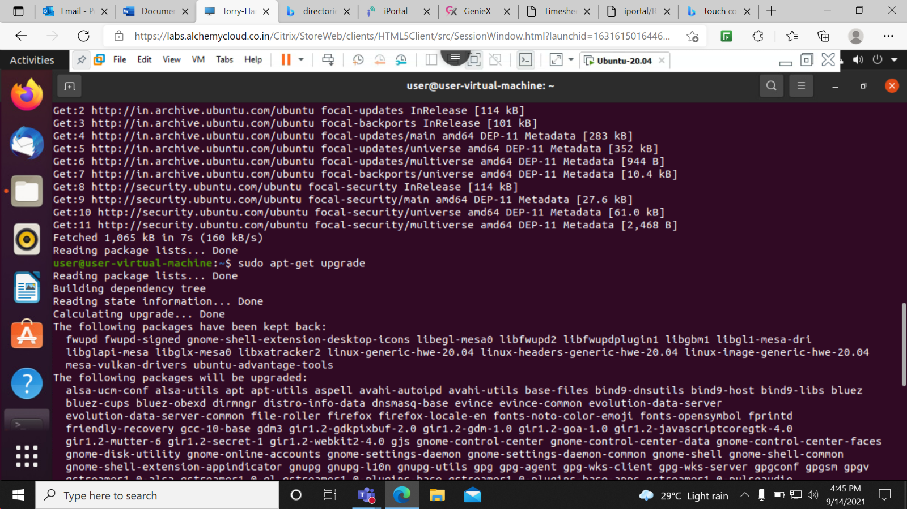

sudo apt-get update && upgrade- This command is used to do both tasks at a time.

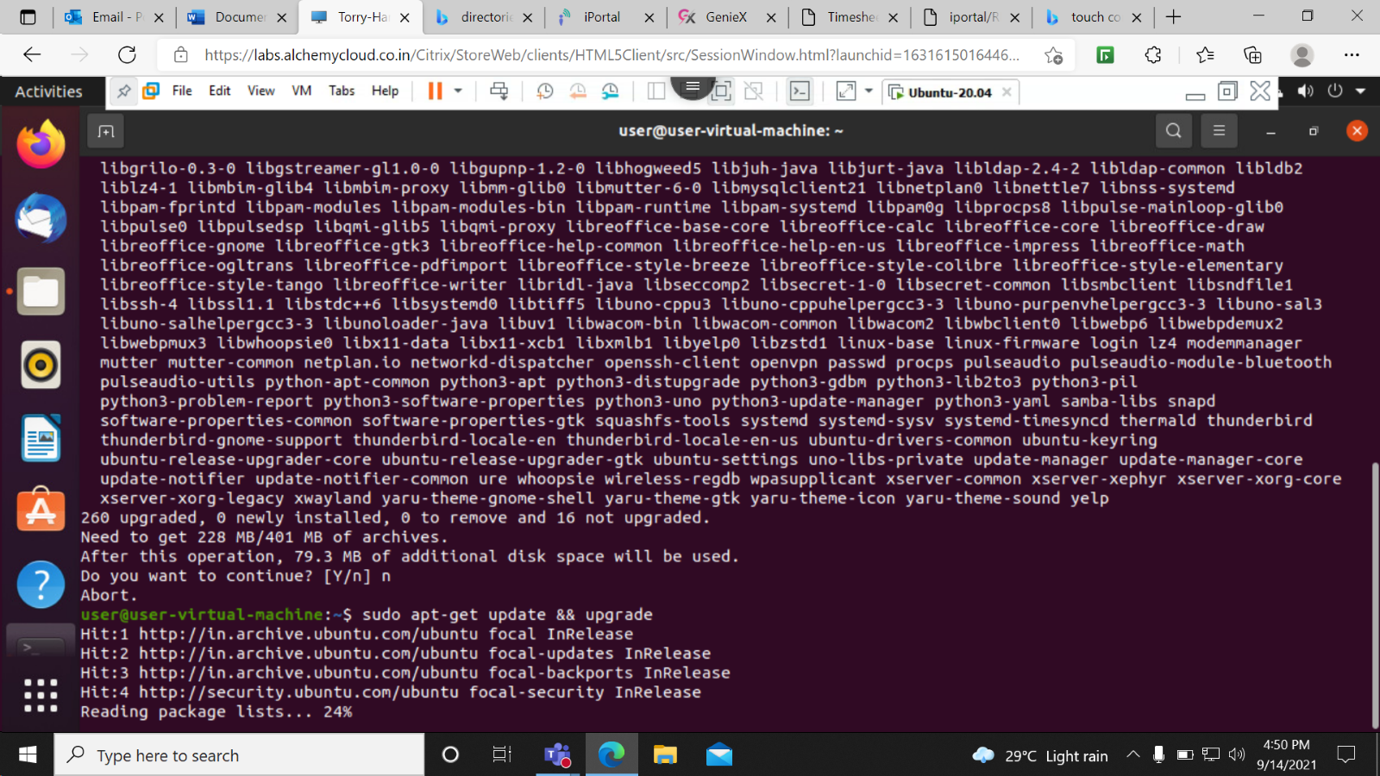

tree /etc-This command is used to display all libries in the system.

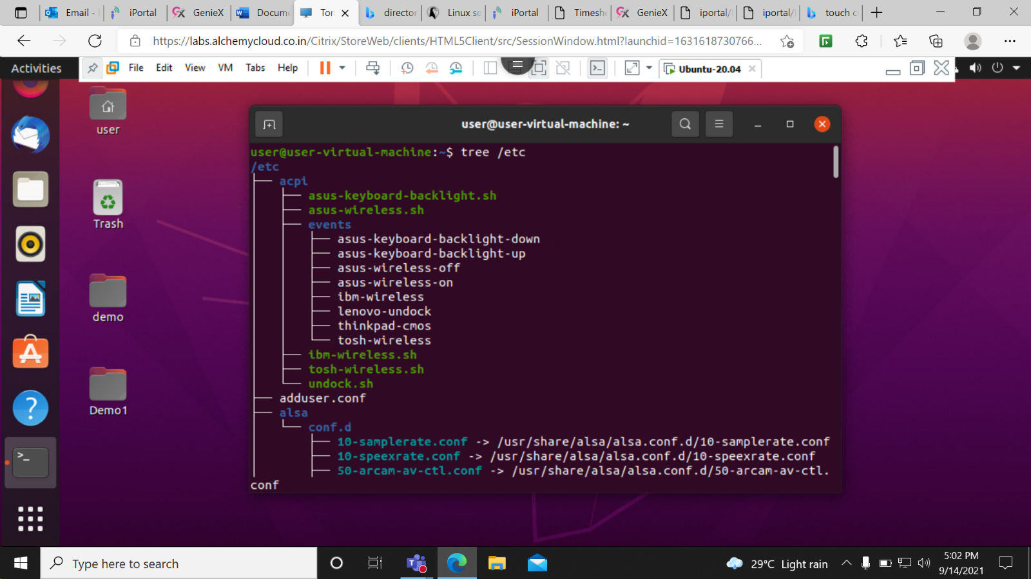

Sudo apt-get remove tree- THis command is used to remove or delete the tree package from system.

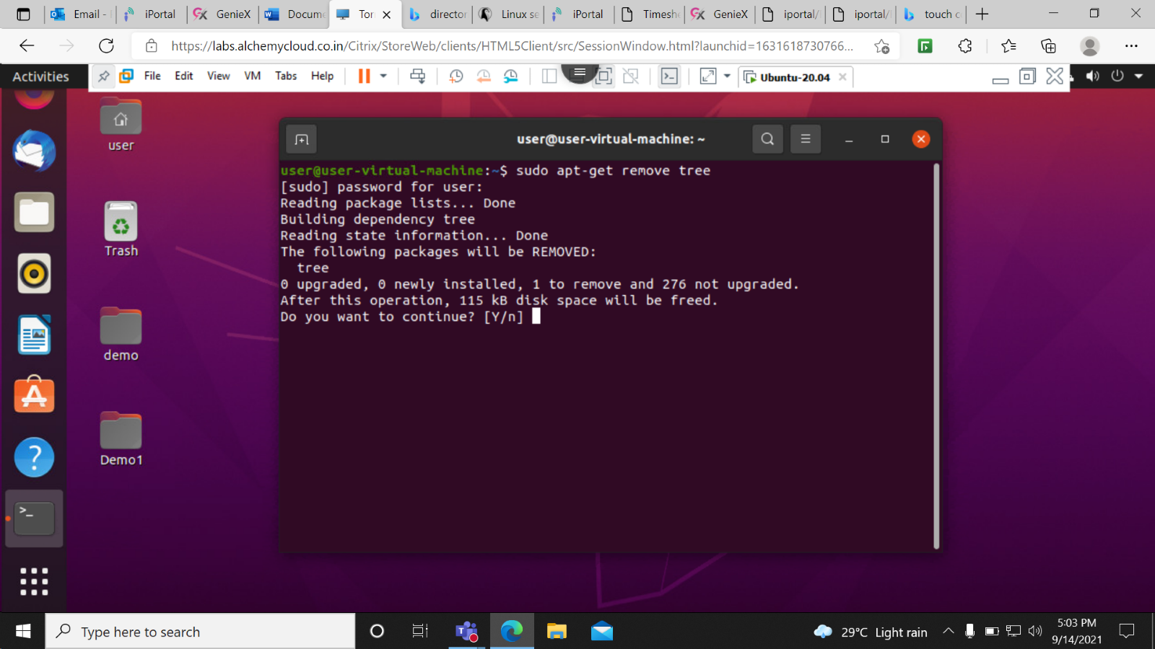

cd ~- This commond is used to return on root folder.

